Hotel Rate for Conference AIR 2017
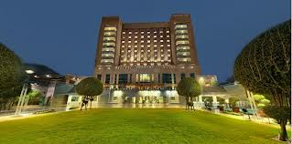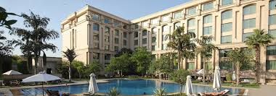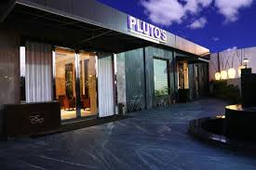
The Jaypee Vasant Continental Hotel The Grand Hotel The Pluto Inn Hotel

S.No | Category | Name of the Hotel | Location/approx dist. From Venue | Special Rates SGL/DBL
1 | 5 STAR | The Grand New Delhi  Vasant kunj | 4 Km From Venue | SGL : Rs.9000/DBL Rs.9500 per day
2 | 5 STAR | Hyatt Regency Delhi  Bhikaji Cama place | 4 Km From Venue | SGL : Rs 9000 /DBL : Rs9500/-. per day
3 | 5 STAR | Hotel The Ashok  Chankya puri | 4 Km From Venue | SGL: 7500/- DBL: 8500/-per day.
4 | 5 STAR | Jaypee Vasant Continental, New Delhi | 4 km from  Venue | SGL: 7800/- DBL: 8500/- per day.
5 | 3 STAR | Hotel Pluto Inn  Vasant kunj | 3 Km From Venue | SGL : Rs.3800 /DBL : Rs. 4300 per day
6 | 3 STAR | The JRD Luxury Boutique Hotel Safdrajung enclave | 4 Km from  Venue | SGL : Rs. 3800/ DBL : Rs.4200 per day
7 | 2 STAR | Hotel V.M. Residency  Vasant kunj | 4 Km From Venue | SGL : Rs 2200 /DBL Rs 2500 per day
8 | G.H. | USO House, Qutab Institutional Area  (approved) | 1 Km From Venue. Walking distance from venue. | Rs 1100/ per pax. 4 pax min. Room with ac and breakfast.

- NOTE:
- All rates are specially negotiated for the event.
- We are providing FREE airport pick up for all 5 star property.
- Above rates are inclusive of breakfast & taxes.

ONLINE PAYMENT by credit card :
- For online payment visit our website www.nammsgroup.in
- Only VISA & MASTERCARD are accepted
* Bank handling charges extra

Namms Tours & Travel
Conferences & Exhibitions Pvt Ltd
Head Office:
India:Land line: +91-11-26176202 / +91-11-26164282 / +91-11- 41359344
Gsm :+91-9810065266 /9911565266
Email :namms.travel@gmail.com & namms.travel@nammsgroup.in
Website:www.nammsgroup.in
Skype ID : nammsgroup

ACCOMMODATION/TOUR & TRAVEL FORM
Family Name: Dr/Prof/Mr/Ms……………………………………………………………………………………………………………..
First Name:……………………………………………..Middle Name:………………………………Sex: M/F………………………
Designation/Post held:…………………………………………….
FullAddress………………………………………………………………………………………………………………………………………….…………………………………………………………………………………………………………………………………………………………….
City:……………………..State:………………………………….Postal Code:………………………Country:………………………..
Telephone:…………………………………Fax:……………………………………….Email:……………………………………………….

PASSPORT DETAILS (For Foreign Delegates)
Passport no.------------------------------------- Place of Issue -------------------------------------------
Place of Birth -------------------------------- Date of Issue -------------------- Date of Expiry-------------------
ACCOMMODATION REQUIRED YES NO
TYPE OF ROOM REQUIRED: Single Double No.of occupants
Arrival date: Departure date: Total nights
NAME OF THE HOTEL (Any two preferences)
1. 2.
FLIGHT DETAILS:
Do you require arrival transfer YES NO Per transfer cost Rs.

ARRIVAL
Date: Time: Flight Number From To

DEPARTURE
Date: Time: Flight Number From To

Please return duly filled form to NAMMS TOURS & TRAVELS by date along with 1 night advance payment for accommodation and tours at below address:
Namms Tours & Travels
Address:-108-109, Gyandeep Complex, 66-A, Laxmi market, Munirka, New Delhi-110067 (INDIA)
Tel: +91-11-41359250/26164282/26106731 :Mobile: +91-9810065266/9911565266
Email :namms.travel@gmail.com/namms.travel@nammsgroup.in :Website: www.nammsgroup.in
Option 2 – Telegraphic transfer

- ACCOUNT NAME: Namms Tours and Travels
- ACCOUNT NO. – 000705500075
- BANK: ICICI BANK,
- BRANCH: Connaught Place, New Delhi - India
- ICICI BANK SWIFT CODE: ICICINBBCTS
- IFSC CODE:ICIC0000007
*Bank charges shall be borne by the remitter
Option 3 – Demand Draft

- Demand draft to be issued in favor of “Namms Tours & Travels” payable at New Delhi
- Address: 108-109, Gyandeep Complex,66-A, Laxmi Market, Opp. Canara bank, Munirka, New Delhi-110067 ,INDIA

